Ocean Adventures: Saturday Science 2016 (Grades 3-4)

Week 1: Introduction to Oceans

Activity 1—Ocean all Around Warm-up Activity

Key Concepts: The ocean is the world's largest marine habitat and covers about 70% of t he Earth's surface; scientists break up the ocean into coastal habitats and open ocean habitats, the open ocean is divided into benthic zone (bottom) and pelagic zone (everything above). Pelagic zone is divided into photic zone (has sunlight), disphotic zone (twilight) and aphotic zone (darkness).

Game—(make sure students are paying attention and respect others)
1. Have students stand in a circle, pass out post-it notes to mark their spot
2. Use a globe to point out how all the oceans are connected, Pacific is biggest (can they name the oceans)
3. Explain that you will be asking a series of questions. If a student can answer YES, they must move to a new spot following the direction of the teacher (i.e. swim like a shark, crawl like crab etc)
4. Once students find their new space, teacher will ask a reflection question
5. After the game, have students return to their seats, say you've been asking them "I wonder questions" now have them write their own "I wonder" questions about the ocean on a sheet of paper. Tape them to the front of the room, we will try to answer these as we go along!—this is what scientists do, they ask questions and try to find answers. We will be investigating many questions today!—(intro science notebook)

Activity 2-- Ocean Density Activity:
- Write the following definition of density on the board:
  - Density is the weight of a liquid divided by the space it occupies.
- Tell students that the following experiment involves a comparision between the density of fresh water and salt water.
- Divide students into small groups and distribute the cup measures, eye dropper, eggs and glasses to them.
- Ask the students to fill one of the glasses with 1 cup of water.
- Direct the students to gently drop one egg into the water and watch what happens.
- Ask students to fill the second glass with 1 cup of water and 1/4 cup of salt.
- Tell them to stir until the salt is completely dissolved.
- Ask students to add a few drops of food coloring to the salt water and allow it to sit for five minutes.
- Direct the students to carefully and slowly add fresh water using the eye dropper, being careful not to disturb the settled colored salt water.
- Tell students to drop the second egg into the glass and watch what happens.
- Have a class discussion using the following questions:
  - Compare the way the two eggs float. Describe the differences.
  - Why do you think the eggs float differently in the separate glasses?
  - What conclusions can you draw about the density of either the eggs or the water?
- After the students have shared their thoughts, explain that the egg sunk in the fresh water because it had greater density than the water in that situation. The egg floated in the salt water because when salt is added to water its density becomes greater than that of the egg. That makes the egg float.
- Ask students what implications this might have in the ocean.
Activity 3-- Zones of the Ocean Activity
1. Explain the zones of the ocean
2. Designate each group to be responsible for one zone of the ocean—draw it on a piece of butcher paper.
3. Have them color their zone/habitat (open ocean, beach, rocky shore, kelp forest, arctic, coral reef, photic zone, sea floor)
4. Connect the zones together to form a big picture
--At this point, if time allows, review adaptations
5. Designate an animal (or two) for each student. Have them learn about that particular animal, focusing on where it might live. Have them color the animal. Then we put them onto our connected picture
Examples of cards (also included at end): https://coast.noaa.gov/data/SEAMedia/Lessons/G3U2L2%20Creature%20Features.pdf

Last Activity: Introduction of tracking animals, we will track sharks and turtles all the weeks.

Shark Tracking Website:

http://www.ocearch.org/

Turtle Tracking Website:

http://www.conserveturtles.org/seaturtletracking.php?page=currentsatelliteturtles

DEEP SEA ANGLER FISH | LANTERN FISH
GIANT SQUID | 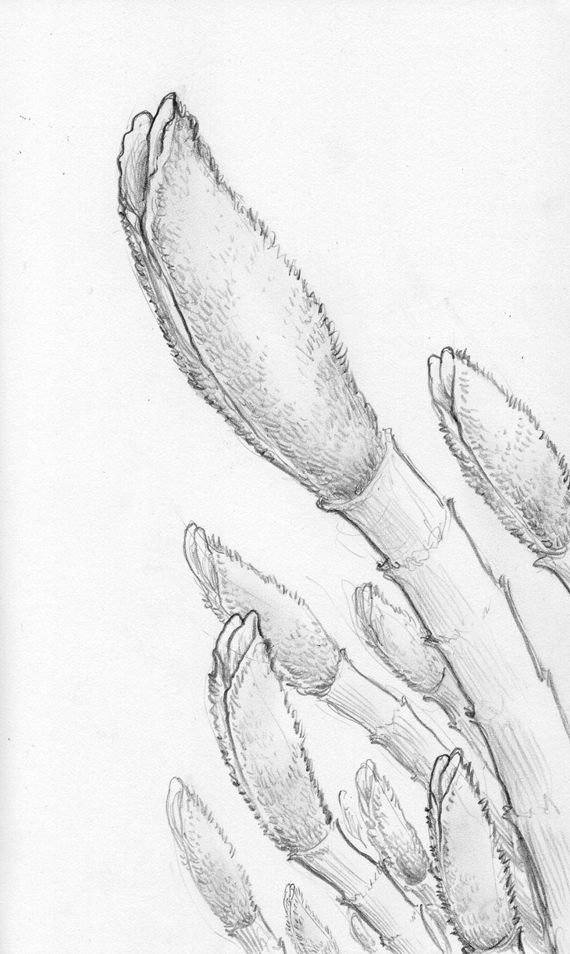  GIANT TUBE WORM
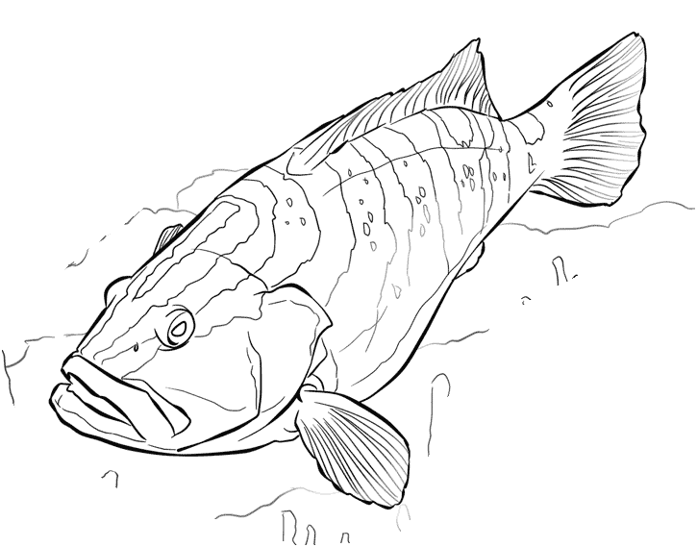  GROUPER | 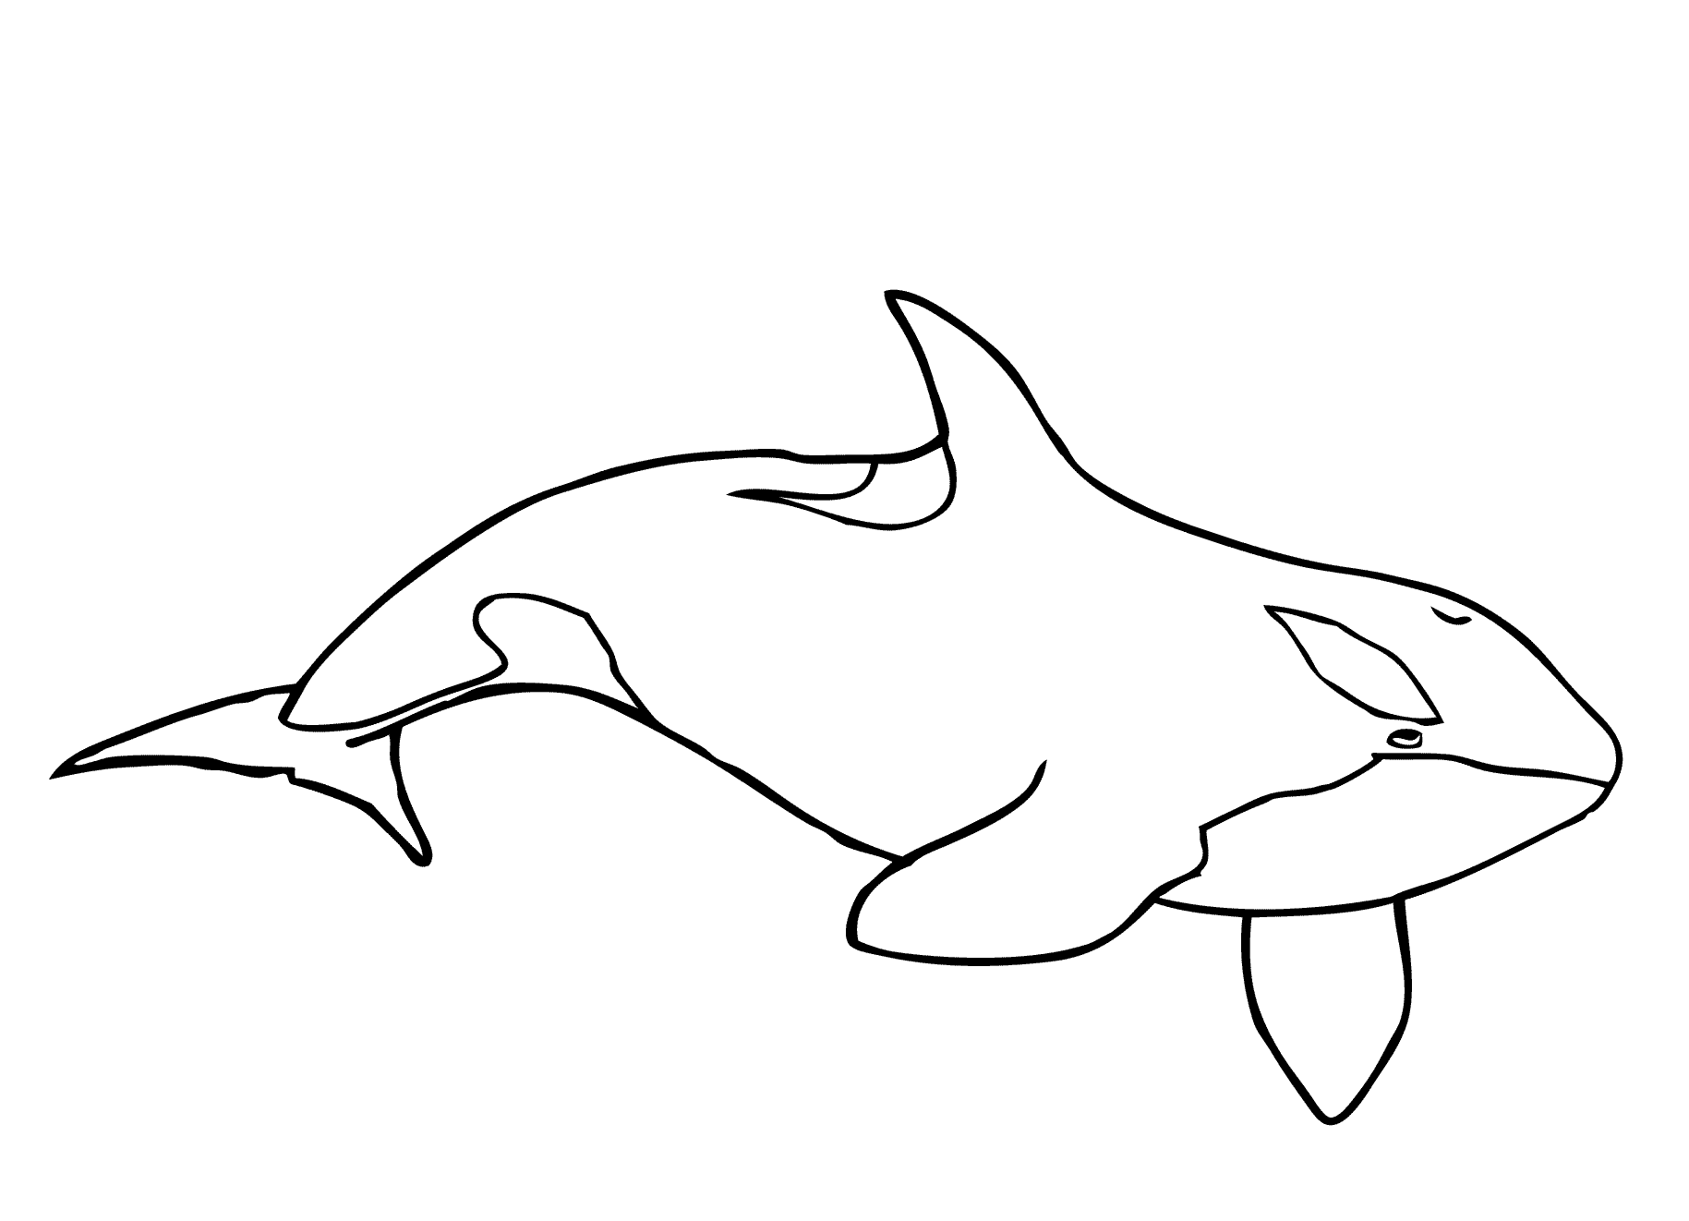  ORCA
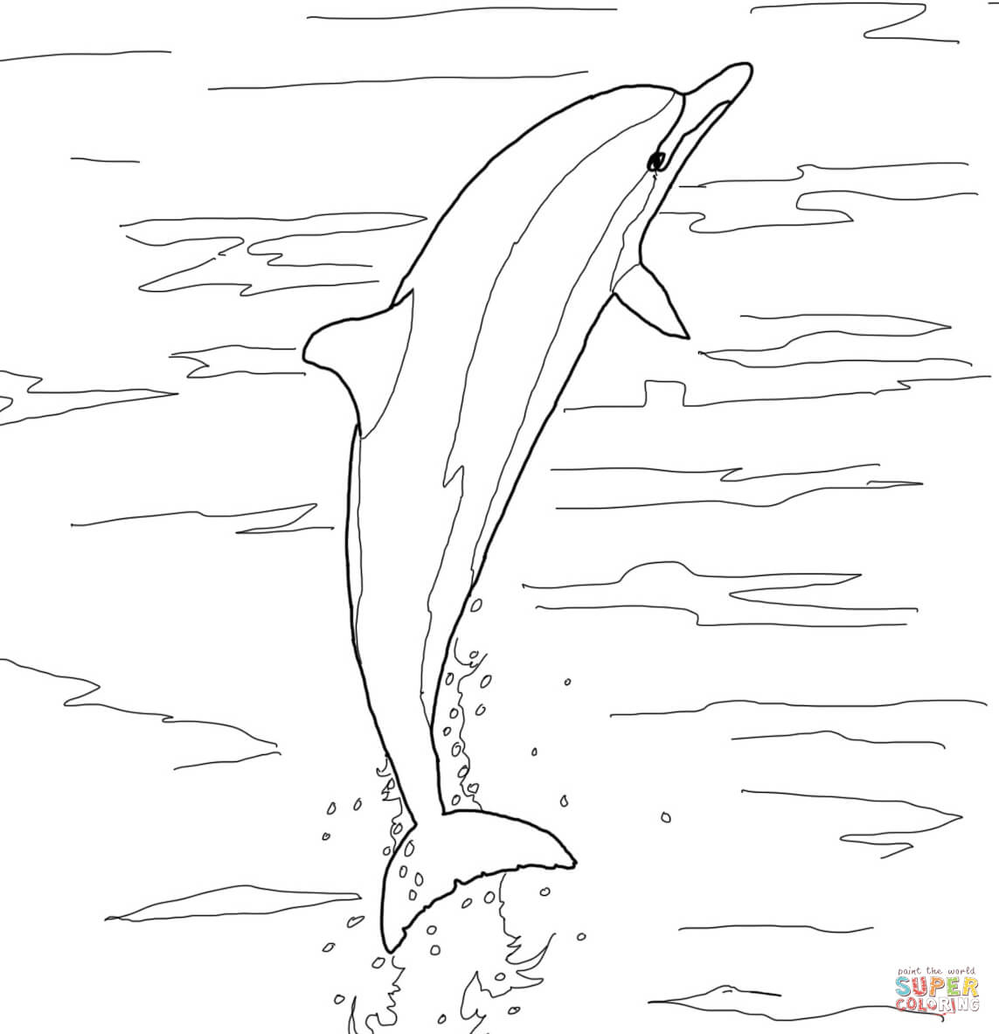  SPINNER DOLPHIN | 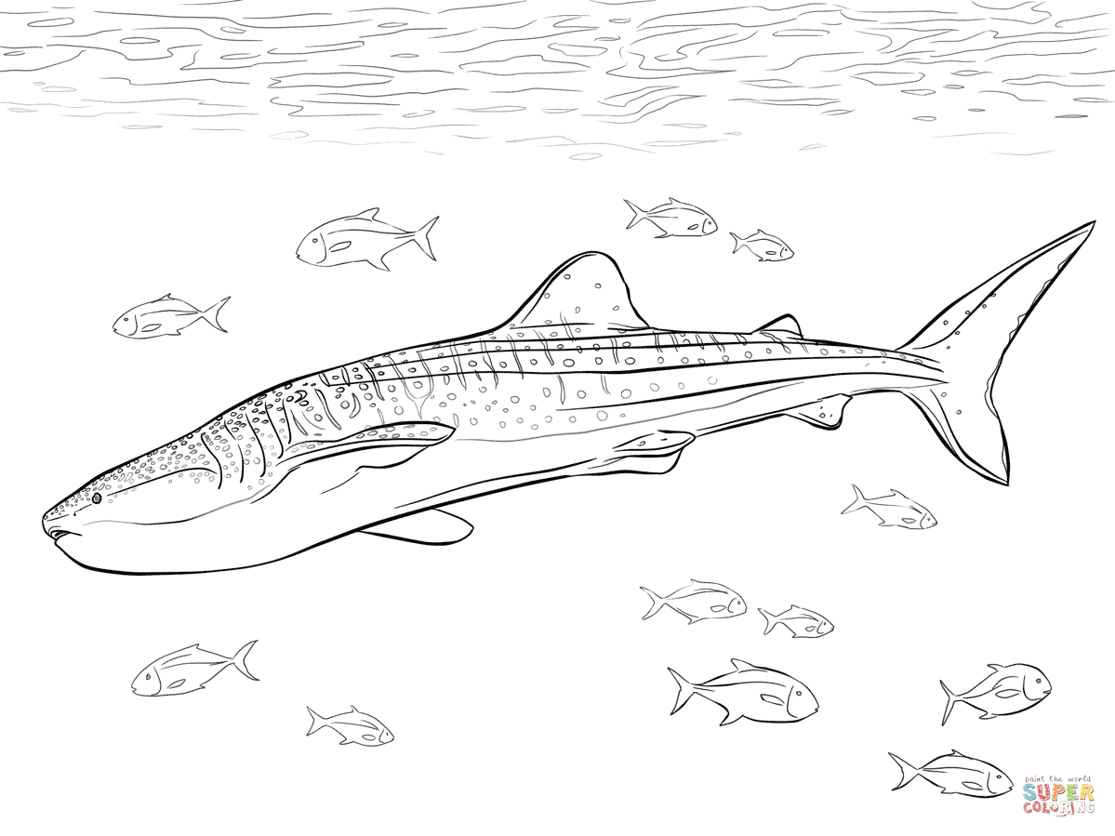  WHALE SHARK
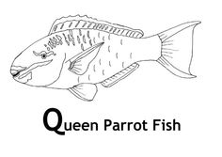  PARROTFISH | 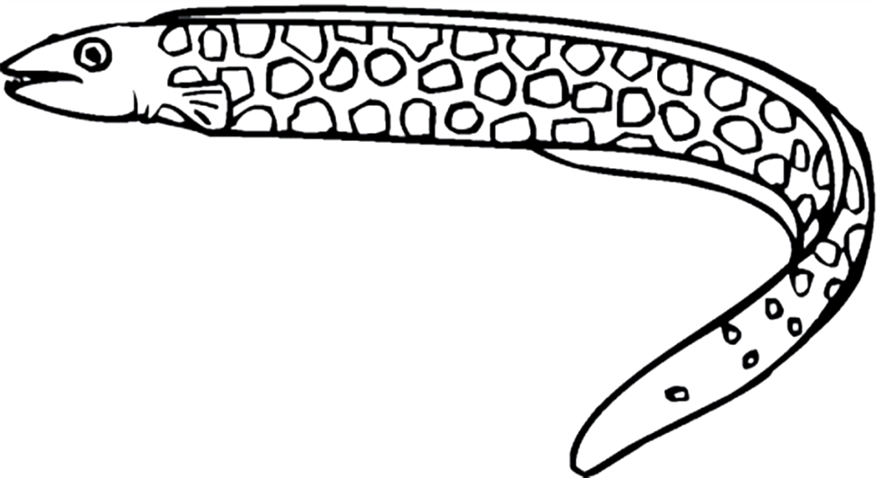  EEL
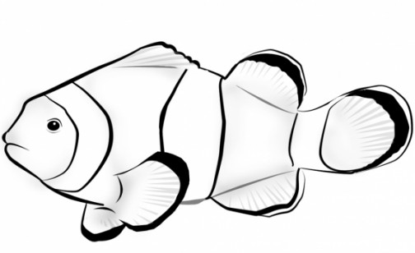  CLOWN FISH | GREEN SEA TURTLE
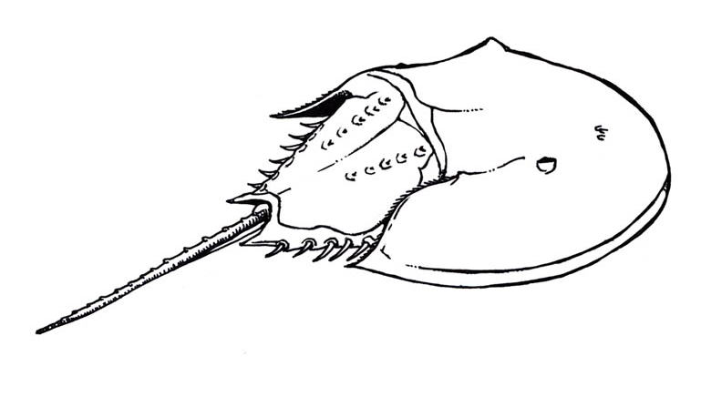  HORSESHOE CRAB | 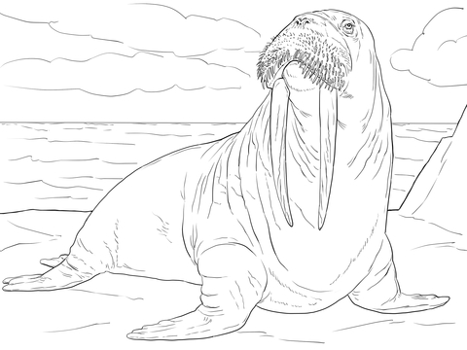  WALRUS
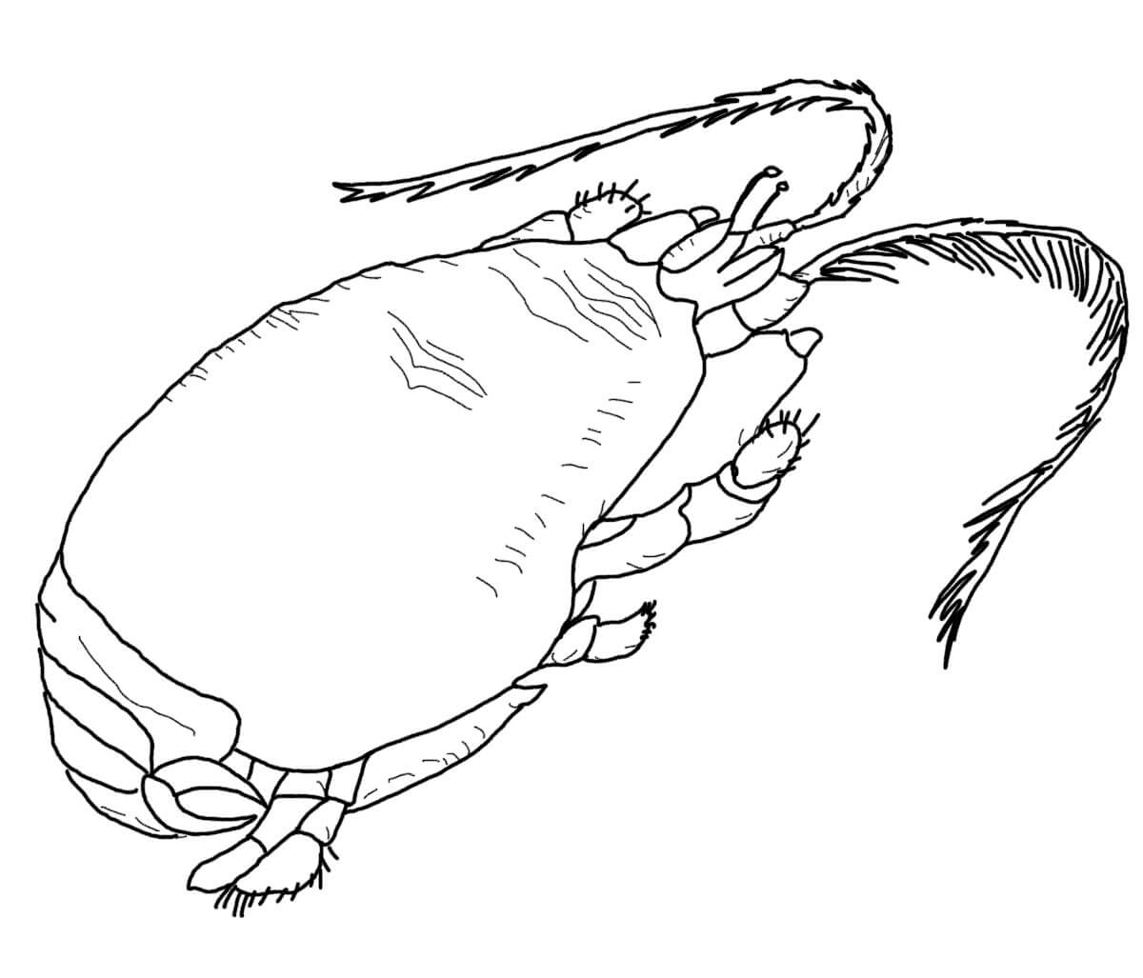  SAND CRAB | 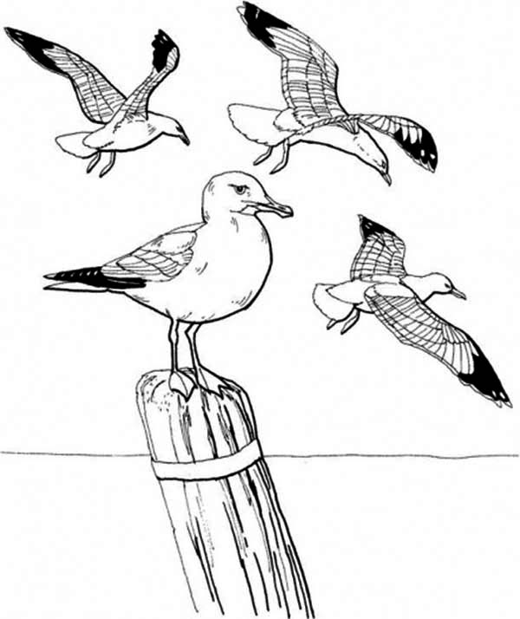  SEA GULLS
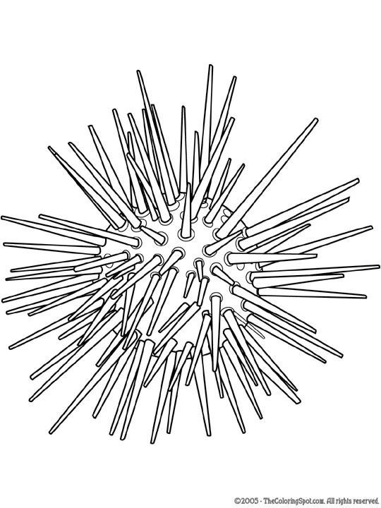  SEA URCHIN | 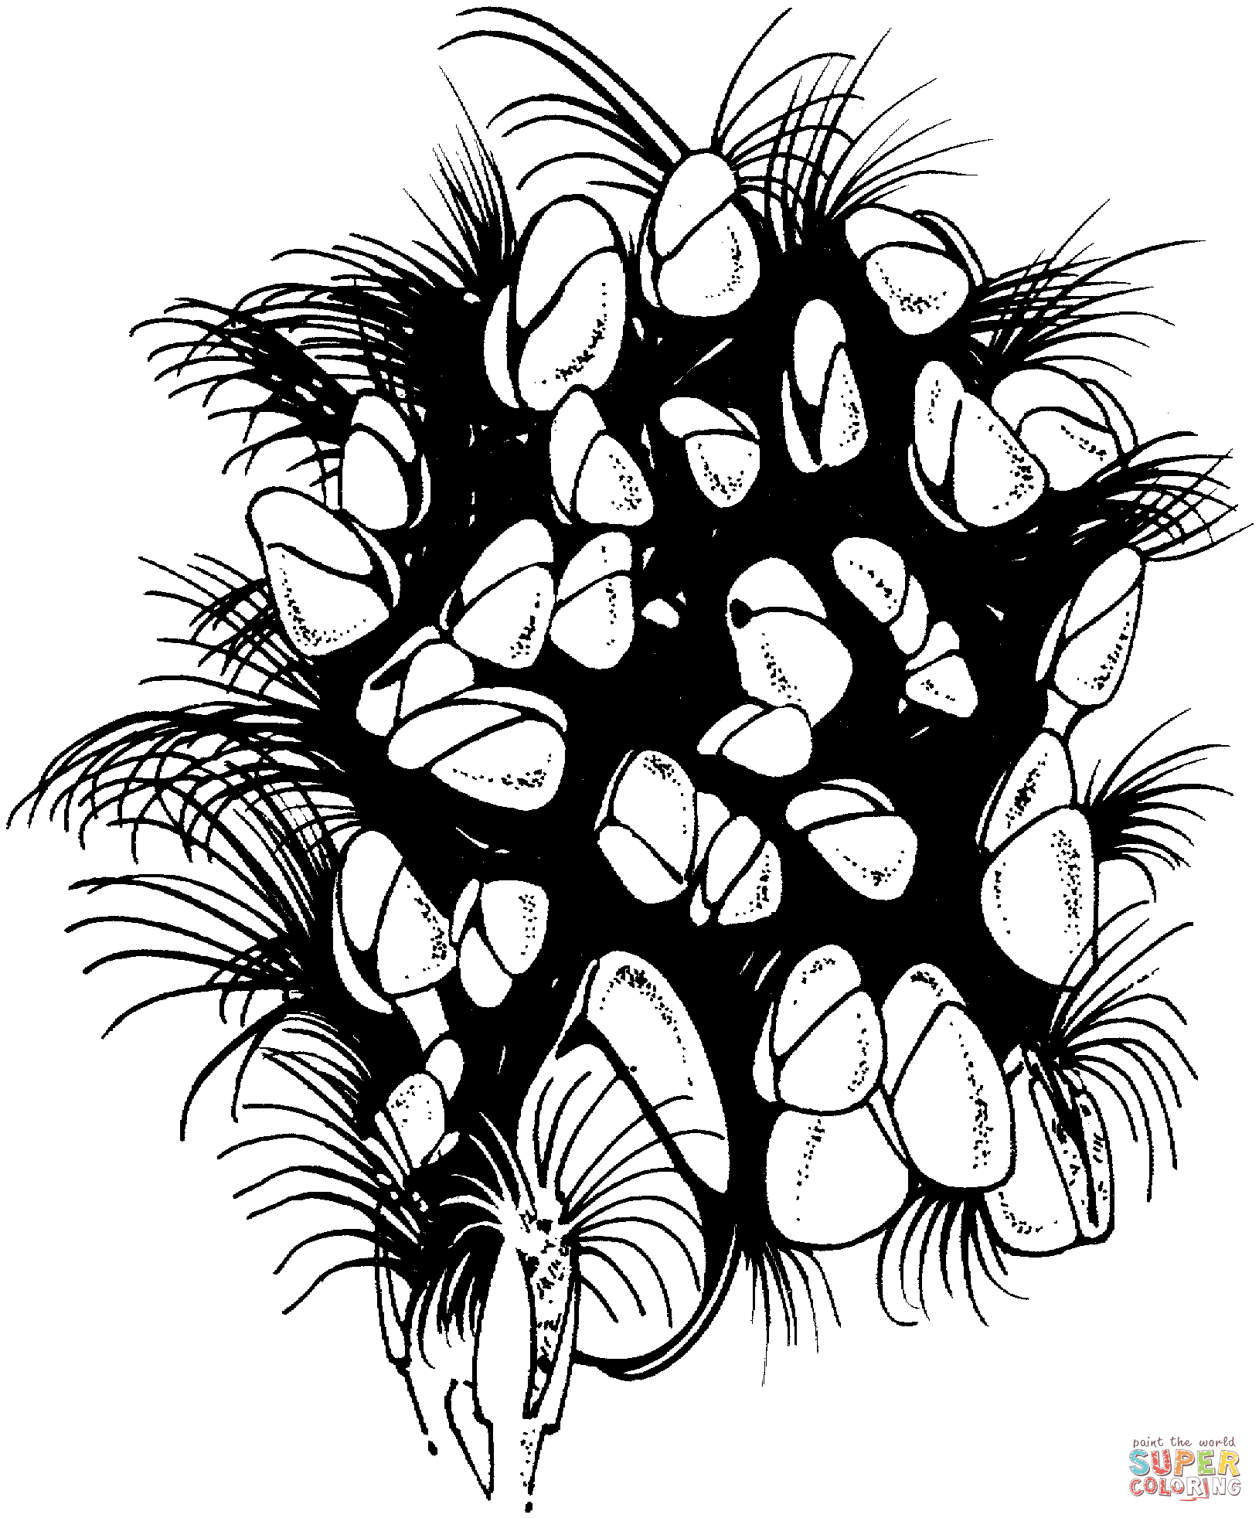  BARNACLES
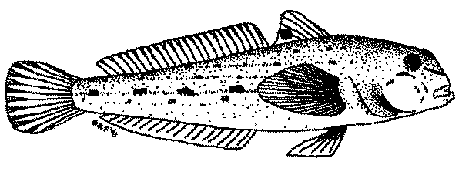  GOBY | 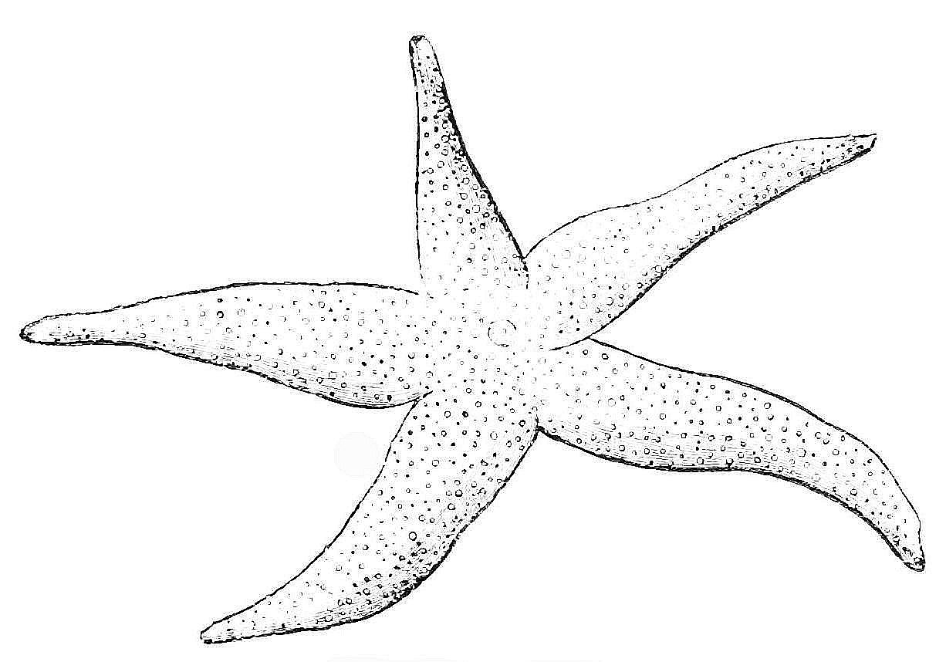  STAR FISH
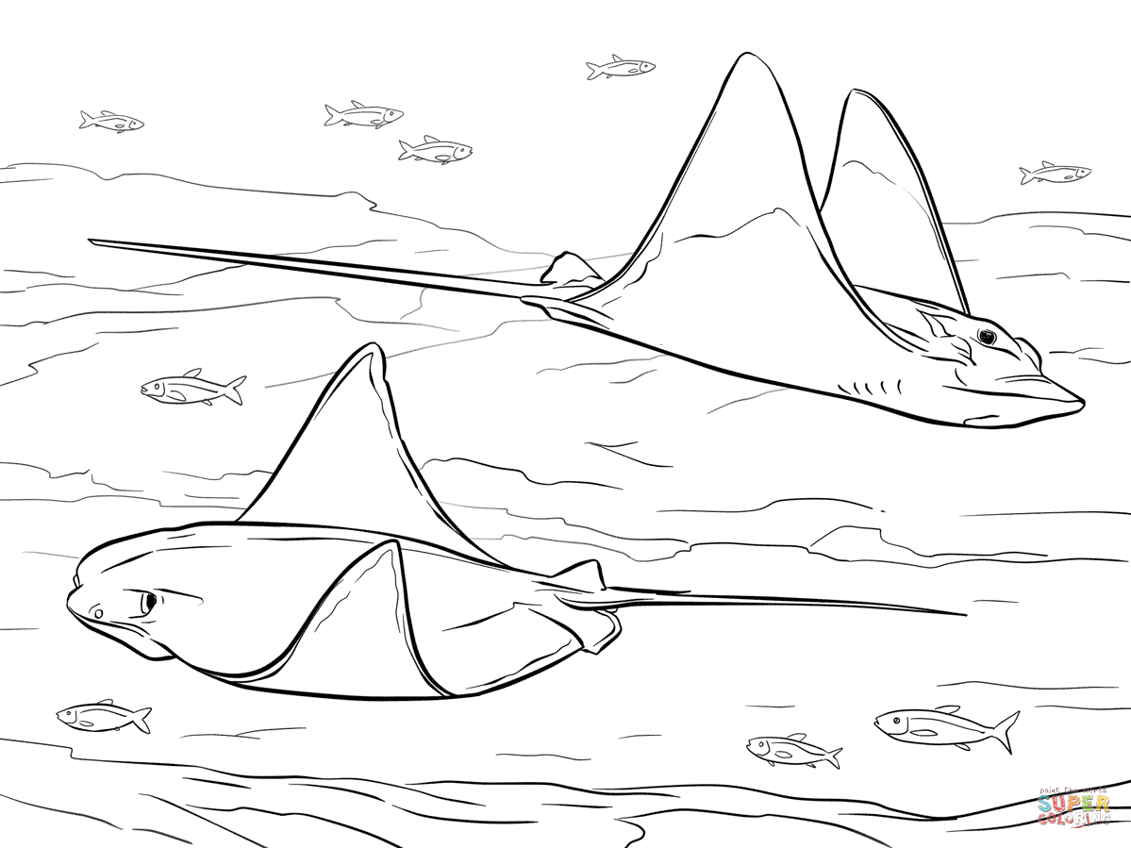  STINGRAYS | 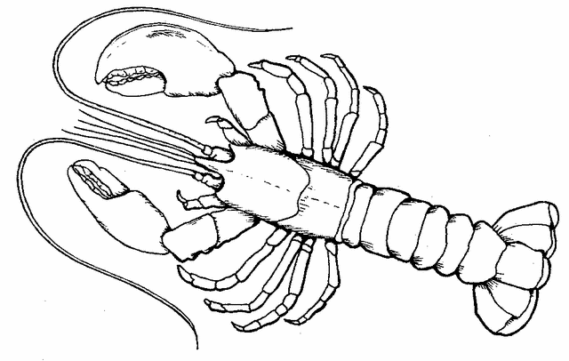  LOBSTER
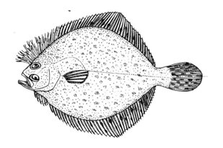  FLOUNDER | 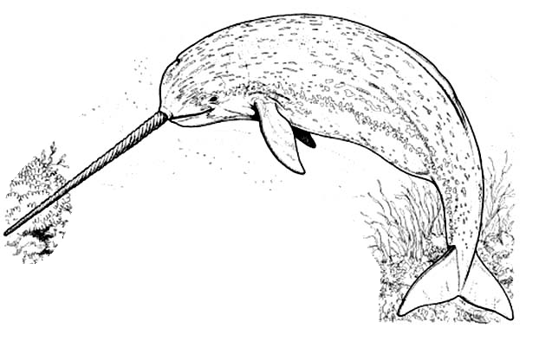  NARWHAL
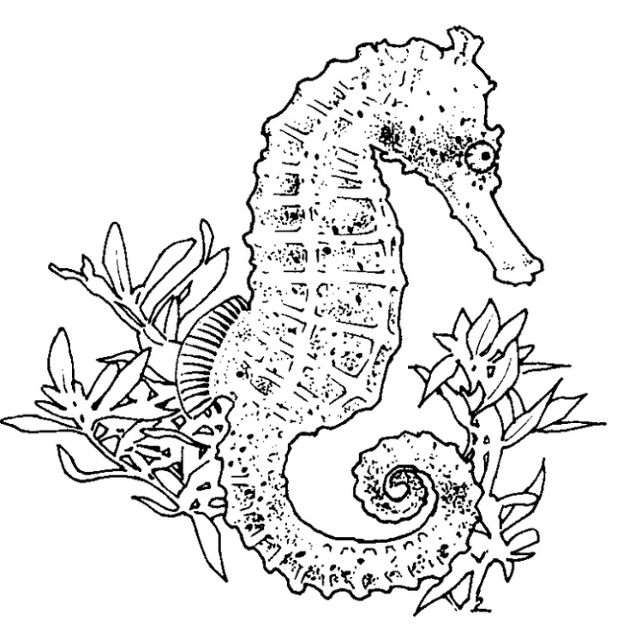  SEAHORSE | JELLYFISH
HUMPBACK WHALE | 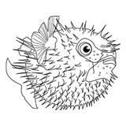  PUFFER FISH
KRILL | TIGER SHARK
ZOOPLANKTON | PHYTOPLANKTON

Week 2 Ocean: Saturday Science Lesson Plan

Design a fish
-Students are given a small sheet of paper to design a fish with adaptations that can help it survive in the ocean zone they are designated.

-We will add these drawings to our posters of the ocean zones from week one and have students explain how their fish survives

Build Your Own Sea Turtle

Materials:
2 paper plates
Glue
Scissors
Construction paper
Crayons/markers

Procedures:
1. Collect the materials
2. Face one plate bottom up; this will be the turtles shell. On the plate draw a design or color to match one of the 8 sea turtles found in the oceans
3. Copy or trace pattern provided or create your own on cardstock.
4. Cut out body parts.
5. Arrange your shapes so that the head is between the two largest flippers and the smaller flippers at the other end.
6. Glue your pieces to the inside of either of your plates.
7. Apply glue to the rim of the other plate and attach both plates facing each other bottoms out.

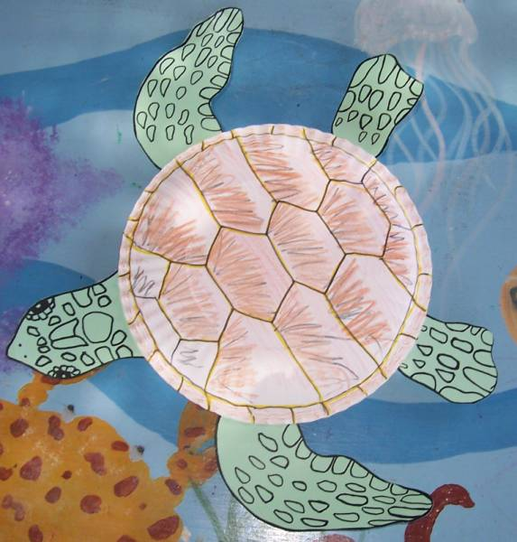

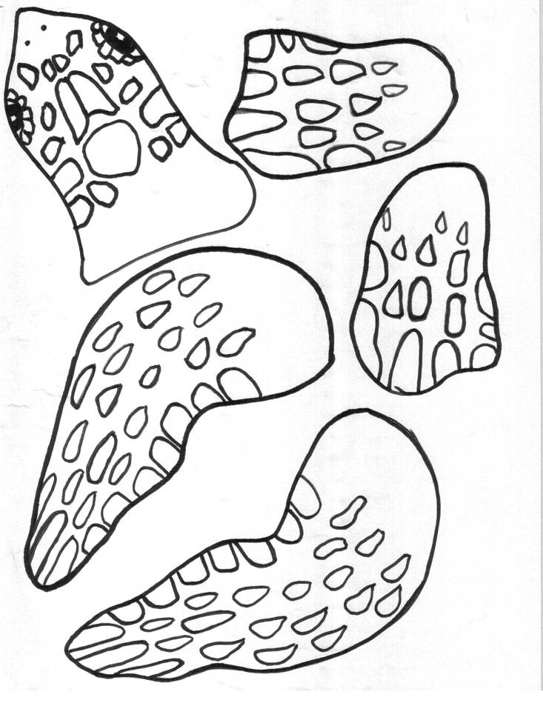

Sea Turtle Game

Materials: Rope or hula hoops, one paper or plastic bag per student, buckets or trays, identity cards for turtles (from build a turtle) and identity cards for predators (can be drawn by students), wooden clothes pins, poker chips or equivalent, dried beans

1. Set up activity area consisting of a large open ocean zone, two "safety zones" and a beach.

2. Divide class into 2 groups—turtles and limiting factors. Turtles should count out 50 beans and put them in their bag. Beans represent turtles that hatch from a single nest

3. Divide the limiting factors group into two smaller groups: on land (raccoons, dogs, gulls, dune buggies, human egg collectors, shoreline development) and In-sea (sharks, killer whales, fishing gear, eating plastic litter, illegal killing). Pin identification to the student.

4. Explain the following rules:
a. Turtles must hatch, cross the beach, and spend 10 years in the open ocean. The turtles run between two buckets (set up at opposite sides of the ocean) to collect poker chips which each represent two years. They can only pick up one chip from the bucket at a time and must alternate between the buckets. After collecting 5 chips, the turtle can return to the beach to reproduce
b. Turtles try to avoid limiting factors and predators. If tagged by a limiting factor, a turtle stops, counts out 10 beans, and places those 10 beans in the limiting factor's bag.
c. The safety zones (hula hoops or rope placed in two spots in the ocean) represent sea grass areas where limiting factors cannot tag them.
d. Limiting factors must obey the following
-They cannot tag the same turtle twice in a row
-Cannot tag turtles that are counting out beans currently
-Must stay at least 4 steps away from any turtle currently transferring beans
e. Any turtle that loses all 50 beans is dead. It must go to the beach and become a condominium. If the condominiums side by side block the access to the beach, the remaining turtles die.
f. Activity ends when all thrutels are either dead or return to the beach

5. After completion, encourage students to discuss the results and describe the life cycle of the
sea turtle. What would happen if all the human limiting factors were gone?

Ocean Lesson Plan Week 3

Background Knowledge and Key Points:

-Understand the work of real scientists and how they gather data from the ocean
-Understand the size of a whale relative to us
-Understand the use of modeling to make life-size models
-Understand how sharks use their fatty liver to stay afloat

1. Brainstorm Questions for the Marine Biologist

--While brainstorming, update tracking journals

2. Skype with Real Live Scientist stationed in Madagascar

3. Snack time videos (Jellyfish)

https://www.youtube.com/watch?v=GlBCAv4qCc0

https://youtu.be/n232p3oP1y0?t=838

https://www.youtube.com/watch?v=vefspwrqJWI

https://www.youtube.com/watch?v=VaMhTqnmppE

4. Draw a Whale

a. Provide students with "pattern" of whale with numbered boxes. Have them practice transferring the pattern to a large sheet of paper
b. Head outside and have students construct a large grid using sidewalk chalk. Squares should be 5ft x 5ft
c. Assign each student one or two boxes in the grid to transfer the lines from the whale
pattern.
d. After everyone has drawn their piece, it should connect into a 50ft humpback whale
f. Review whale adaptations

5. Sharks

Lesson from:
http://www.connectionsacademy.com/resources/instructographics/shark-science-activity

We constructed the sharks using plastic cups since these did not get wet in the water.
-Have students add fins and pennies to their shark using the hot glue gun (with supervision)
-Decorate with permanent markers (so doesn't wash off in water)
-Add the "fatty liver" by filling a balloon with vegetable oil
-Sharks should float with the fatty liver (review adaptations)

Oceans Week 4 Lesson Plan

Manta Ray Activity

From: http://www.jason.org/sites/default/files/Secrets_of_the_Gulf_Sampler.pdf

-Students are assigned to be either a manta ray or a scientist
-Scientists are asked to carry a clipboard and keep track of the manta rays they see in the ocean. They must use binoculars and not touch the manta rays (as their skin is very sensitive).
-Manta rays flap their wings through the water and generally try to avoid the scientists
-Scientists will discover that not all species of manta ray have previously been discovered

Coral Reef Construction

From: http://coralreef.noaa.gov/education/educators/resourcecd/activities/resources/construction_sa.pdf

-Students build a coral reef out of clay, play-dough, and pipe cleaners. Stick the clay to the bottom of a container filled with water and sand. Stack playdough on top of this. Pipe cleaners represent new polyps forming. If they fall out of the playdough that polyp has died and cannot reproduce. Polyps that survive can reproduce and pipe cleaners can be added nearby

Lantern Fish
From: http://www.montereybayaquarium.org/animals-and-experiences/family-activities/lanternfish-sticks

Week 5 Lesson Plan

Key Points:
a. Understand how scientists learn about the ocean and ocean animals
b. Practice skills such as scale drawings, making models, and graphing
c. Use knowledge of adaptations to make practical suggestions for studying animals

1. Divide class into "research teams"—research teams should design their vessel and a flag for a sea expedition

2. Each team has been designated an animal for study. Their task is to design a tracking device that can be fitted to their animal. In order to do this, life-size models of the organism should be made so that the tracker can be retrofit to the animal. They will then design and build a model of the tracker and designate how it will attach to the animal. Teams will collaborate and then share designs with other teams.

a. The first task for the research teams is to draw the scale model of their animal .
b. Second task is to design their tracker
c. Third task is to build a model of their tracker and fit it to the scale model of their animal.

3. Students are asked to lower their "hydroscopes" into the water to listen for whale sounds. After some "recordings" are taken, we will create "spectrographs" of the whales so we can identify them later.

a. Play the sound of the whale
b. Instruct students in an example where they are prompted to make an "upward" line if the sound goes up, a "downward" line if it goes down, and a straight line if it is a click.
c. Each team will be assigned two recordings:

Team 1:
Orca 1: http://bbnc-dev.vanaqua.org/document.doc?id=34
Humpback: http://hawaiihumpbackwhale.noaa.gov/explore/sounds/whale_song.mp3

Team 2:
Orca 2: http://www.wdcs.org/wdcskids/en/story_details_wow.php?select=632
Humpback (Theme 1): http://www.whaletrust.org/what-we-do/humpback-whale-research/whale-song/song-structure/

Team 3:
Orca 3: http://www.orcaresearch.org/wp-content/uploads/2011/08/AUDIO_11.mp3
Humpback (Theme 2): http://www.whaletrust.org/what-we-do/humpback-whale-research/whale-song/song-structure/

Team 4:
Orca 4: http://bbnc-dev.vanaqua.org/document.doc?id=33
Humpback (Theme 3): http://www.whaletrust.org/what-we-do/humpback-whale-research/whale-song/song-structure/

Team 5:
Orca 5: http://bbnc-dev.vanaqua.org/document.doc?id=35
Humpback (Theme 4): http://www.whaletrust.org/what-we-do/humpback-whale-research/whale-song/song-structure/

Team 6:
Orca 6: http://www.orcaresearch.org/wp-content/uploads/2011/08/AUDIO_06.mp3
Humpback (Scroll down to samples): http://www.npr.org/2014/12/26/373303726/recordings-that-made-waves-the-songs-that-saved-the-whales

4. Whale ID-- We want to know the whales that were singing each of these songs. A photograph was taken of each singing whales. Match the photographs to identify each singing whale.

5. Identify Shark Teeth- students will be given a card with two shark teeth and asked to identify what species it came from using a key.

6. Track Animals—The data is in! See where your tagged animals went in the past few months by plotting their points on the graph. (see end)

Extras Activities if time allows:

Periscope
http://www.montereybayaquarium.org/education/classroom-resources/games-and-activities/dive-into-the-deep

Eat or be eaten game https://coast.noaa.gov/data/SEAMedia/Lessons/G3U2L4%20CL%20Eat%20or%20Be%20Eaten.pdf

Whales eating habits-- https://coast.noaa.gov/data/SEAMedia/Lessons/G3U5L2%20Whale%20Feast%20Feeding%20Discovery%20Lab.pdf

WHALE SONG ID

Your hydrophone has picked up some sounds from two Pacific whales. In order to help identify them in the future, our team would like you to make a spectrograph of their sounds.
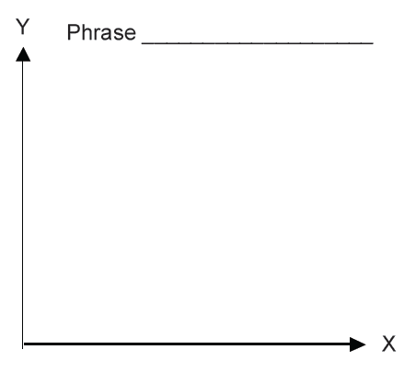
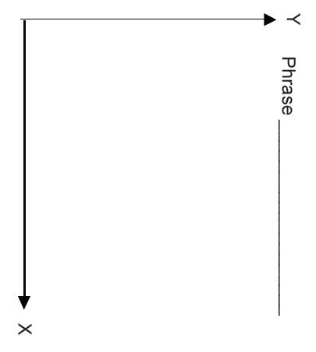

DUSKY- Brown Catshark (M)
POINT | DATE | LAT/LONG
A | Mar 5 | 43ºN 126ºW
B | Mar 25 | 45ºN 128ºW
C | Apr 1 | 50ºN 130ºW
D | Apr 18 | 43ºN 130ºW
E | Apr 29 | 50ºN 135ºW

CHEIF- Scalloped Bonnethead (M)
POINT | DATE | LAT/LONG
A | Mar 5 | 35ºN 122ºW
B | Mar 25 | 33ºN 124ºW
C | Apr 1 | 37ºN 125ºW
D | Apr 18 | 37ºN 127ºW
E | Apr 29 | 32ºN 127ºW

MOLLY- Spinner Dolphin (Juv, F)
POINT | DATE | LAT/LONG
A | Mar 5 | 25ºN 160ºW
B | Mar 25 | 24ºN 157ºW
C | Apr 1 | 23ºN 156ºW
D | Apr 18 | 20ºN 154ºW
E | Apr 29 | 15ºN 153ºW

KENNY- Harbour Porpoise (Juv, M)
POINT | DATE | LAT/LONG
A | Mar 5 | 57ºN 147ºW
B | Mar 25 | 57ºN 150ºW
C | Apr 1 | 55ºN 155ºW
D | Apr 18 | 54ºN 153ºW
E | Apr 29 | 50ºN 160ºW

OLIVE- Olive Ridley Sea Turtle (F)
POINT | DATE | LAT/LONG
A | Mar 5 | 15ºN 120ºW
B | Mar 25 | 20ºN 125ºW
C | Apr 1 | 25ºN 130ºW
D | Apr 18 | 40ºN 129ºW
E | Apr 29 | 45ºN 126ºW

MISTY- Harbor Seal (Juv, F)
POINT | DATE | LAT/LONG
A | Mar 5 | 50ºN 130ºW
B | Mar 25 | 52ºN 133ºW
C | Apr 1 | 53ºN 135ºW
D | Apr 18 | 55ºN 137ºW
E | Apr 29 | 57ºN 140ºW

